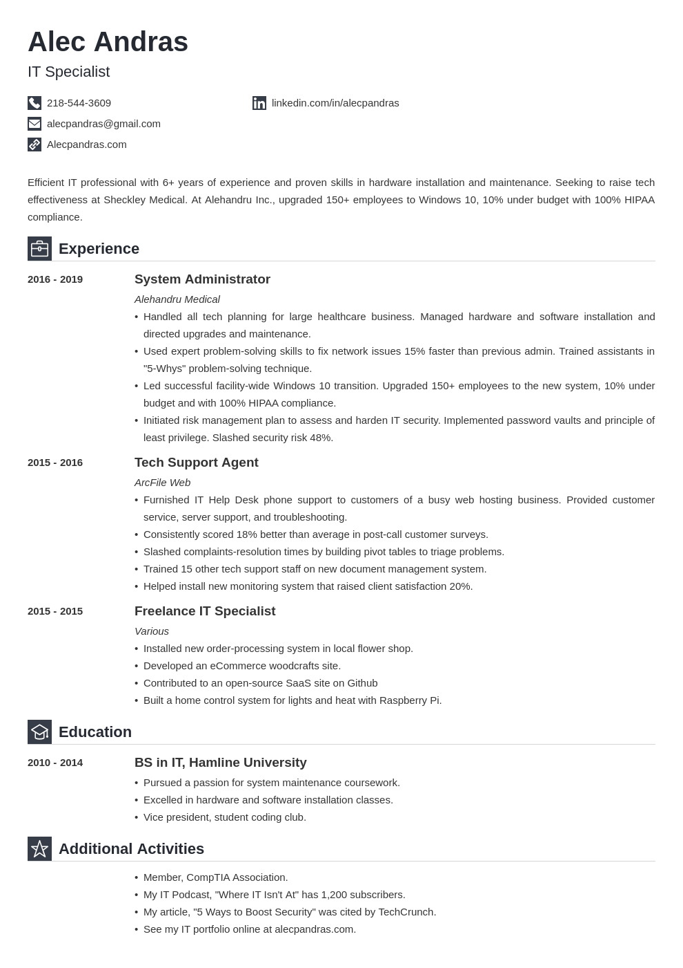
Alec Andras
IT Specialist
218-544-3609
alecpandras@gmail.com Alecpandras.com
in linkedin.com/in/alecpandras
Efficient IT professional with 6+ years of experience and proven skills in hardware installation and maintenance. Seeking to raise tech effectiveness at Sheckley Medical. At Alehandru Inc., upgraded 150+ employees to Windows 10, 10% under budget with 100% HIPAA compliance.
Experience
2016 - 2019
2015-
- 2016
2015 - 2015
Education
2010 - 2014
System Administrator
Alehandru Medical
• Handled all tech planning for large healthcare business. Managed hardware and software installation and directed upgrades and maintenance.
• Used expert problem-solving skills to fix network issues 15% faster than previous admin. Trained assistants in "5-Whys" problem-solving technique.
• Led successful facility-wide Windows 10 transition. Upgraded 150+ employees to the new system, 10% under budget and with 100% HIPAA compliance.
• Initiated risk management plan to assess and harden IT security. Implemented password vaults and principle of least privilege. Slashed security risk 48%.
Tech Support Agent
ArcFile Web
• Furnished IT Help Desk phone support to customers of a busy web hosting business. Provided customer service, server support, and troubleshooting.
• Consistently scored 18% better than average in post-call customer surveys.
• Slashed complaints-resolution times by building pivot tables to triage problems.
• Trained 15 other tech support staff on new document management system.
• Helped install new monitoring system that raised client satisfaction 20%. Freelance IT Specialist
Various
• Installed new order-processing system in local flower shop.
• Developed an eCommerce woodcrafts site.
• Contributed to an open-source SaaS site on Github
• Built a home control system for lights and heat with Raspberry Pi.
BS in IT, Hamline University
• Pursued a passion for system maintenance coursework.
• Excelled in hardware and software installation classes.
• Vice president, student coding club.
Additional Activities
• Member, CompTIA Association.
• My IT Podcast, "Where IT Isn't At" has 1,200 subscribers.
• My article, "5 Ways to Boost Security" was cited by TechCrunch. See my IT portfolio online at alecpandras.com.

